March 2018

Dear Parents,
Welcome to Assumption Parish School of Religion. Attached you will find the PSR registration packet for the 2018-19 school year. Please fill these forms out carefully and completely, as all of the information is needed, and return it to the PSR office by with a $50.00 non-refundable registration fee per student. This registration fee will be applied to your tuition. Classes are filled as enrollments are received. If, after enrolling your child you discover a conflict with your chosen session, I will be more than happy to work with you to make necessary changes.
We need a copy of a Baptismal certificate for all children enrolled in PSR.
We believe that you, as parents, are the examples and leaders of your child’s faith formation and we are here to support you on this journey. When registering your child for PSR, you acknowledge that you will show an ongoing interest in your child’s religious training by regular attendance at Sunday Mass and PSR classes. Parents of children in Sacramental classes will also have sessions to attend. A student may only be placed in the Sacramental Preparation programs (2nd or 8th) grade if the child has attended the previous year of religious training. If you have any questions at all about finances, classes or general information, please call (636)240-1020 or email me at abvmpsr@yahoo.com and I will be very happy to help.
I look forward to having your family in our program and a wonderful year of sharing God’s great love for us!
Blessings,
Ann Marie Quan
Important Dates to Remember
June 30—Enrollment Forms Due with Deposit
August 30—New Family Orientation 6:15-7:15pm
September 4/5—PSR Classes Begin 6:15-7:15pm
CRE-Assumption Parish

Tuition Rates for 2018-2019
- 1 Child………………….............$205
- 2 Children………………………..$365
- 3 or more Children…….….…$485
- Additional Sacrament Fee….$25

Assumption Catholic School-PSR-Registration Form
CHECK ONE:
RE-ENROLL
NEW ENROLL
Return with a $50.00 Registration Fee per student
payable to Assumption PSR
School Name: Assumption Catholic School-PSR Date:__________________
School Year 2018-2019_________________ Enrolling in Grade:_______
Student Information-Complete packet for each child
Student Name: ___________________________________________ Sex: Date of Birth:_________
Last First MI (Jr, III) Male Female mm/dd/yyyy
Session Requested:
_____ Tuesday 6:15-7:15 pm
_____ Wednesday 6:15-7:15 pm
Return registration form with
$50.00 registration fee per student made payable to Assumption PSR
Home Address: ___________________________________________
Street Address Suite #
___________________________________________
City State Zip Code
Email Address: ___________________________________________
Email address where all official communication may be sent

School Attending: __________________________________________

Sacraments: Please check sacraments received.
Baptism Date: ______________ Place: ________________________ (please attach Baptismal Certificate)
Reconciliation Date:______________ Place:_________________________
First Communion Date:______________ Place:_________________________

Family Information

Student lives with: Mother and Father Mother Father Step-Mother Step-Father Check all that apply and

provide information below Legal Guardian** (See note and provide information on next page)

Mother/Step-Mother’s Information
Full Name: ______________________________
Home Address: ______________________________
______________________________
Home Phone: ( )_________________________
Cell Phone: ( )_________________________
Preferred Email: ______________________________
Occupation: _______________________________
Employer: ______________________________
Work Phone: ______________________________ Religion: _________ Parish:_______________
Registered in Assumption Parish: ________________

Father/Step-Father’s Information
_____________________________________________
_____________________________________________
_____________________________________________
( )_______________________________________
( )_______________________________________
_____________________________________________
_____________________________________________
_____________________________________________
_____________________________________________
Religion: ____________ Parish:__________________
Registered in Assumption Parish: ________________

Student Name________________________________________________________

***Only complete this section IF YOU ARE ASSIGNED AS A LEGAL GUARDIAN :

Full Name: ______________________________________________________________________________________________
Home Address: __________________________________________________________________________________________
___________________________________________________________________________________________
Home Phone __(_____)_____________________________Cell Phone_(_____)_____________________________________
Preferred Email __________________________________________________________________________________________
Occupation ___________________________________________________________________________________________
Employer ___________________________________________________________________________________________
Work Phone __(_____)____________________________________________EXT____________________________________
Religion ___________________________________ Parish/Church _______________________________________

**NOTE: Parents who are (or become) divorced, separated, unmarried, or who have any other special circumstances regarding the custody of their children must provide the school with a current court order or decree of custody for the student’s file. Any other specific instructions regarding release of the child or his/her records must be in writing and signed by the parent or parents with court-ordered legal custody. All parents/guardians with legal authority to make educational and religious decisions on behalf of the applicants must sign this form.

Additional Information
If there is any other person/parent that has legal custody, but does not reside with the child, please provide information:
Full Name: _______________________________ Relationship: ________________________________

Home Phone: ( )_________________________ Cell Phone: ( )____________________________

Preferred Email: ______________________________

Religion: ______________________________ Parish/Church: _____________________________

Student Name________________________________________________________

Emergency Contact Information
Please list the names of two adults who should be contacted in the event of any emergency if parents listed above cannot be reached.

Emergency Contact 1
Full Name: ______________________________
Home Phone: ( )________________________
Cell Phone: ( )_________________________
Emergency Contact 2
_____________________________________________
( )_______________________________________
( )_______________________________________

Student Background Information
In order to help us serve your student, please provide the following information. If your student has a current IEP, 504 plan or any other educational documents, please provide copies.

Does your child receive special services from a professional (e.g. counselor, speech therapist, special education teacher)?
NO YES, Briefly describes the type of service, length of service, and if it discontinued a reason for discontinuation:

Does your child need accommodations to be successful in school?
NO YES, Briefly explain the accommodations needed:

Does your child have any diagnosed allergies?
NO YES, please list:

Medical Diagnosis: Please check all that apply:
No known medical conditions *Diagnosed condition (specify): __________________________________
Physical Disability:
No Existing physical disability *Identified Disability (specify): ____________________________________
Learning Disorder
No Known learning disorder *Identified Disorder (specify): _____________________________________

Commitment
Tuition Rates for 2018-2019

1 Child………………….............$205
2 Children………………………..$365
3 or more Children…….….…$485
Additional Sacrament Fee….$25

Office Use Only
Date Received: ________________
Session Assigned:______________
Deposit Received: _____________
Check #:______________________

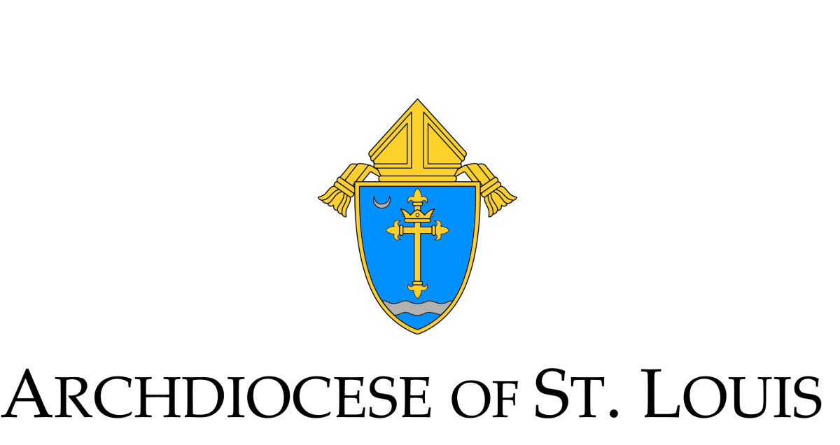

Catholic Education Center Archdiocese of Saint Louis
4445 Lindell Boulevard Witness Statement
Saint Louis, MO 63108-2403

For Those Seeking to Enroll their Children in a Catholic School or a Parish School of Religion
One of the blessings of marriage is bringing forth new life. God entrusts children to parents who have a primary right and duty to educate their children in the practice of the faith. Parents carry out this responsibility by creating a home full of love, forgiveness, respect and fidelity. The family is the community in which, from childhood, one honors God and learns moral values.
In the rite of the Sacrament of Baptism, parents receive the following call from God to evangelize their children:
You have asked to have your child baptized. In doing so you are accepting the responsibility of training her (him) in the practice of the faith. It will be your duty to bring her (him) up to keep God's commandments as Christ taught us, by loving God and our neighbor ... You will be the first teachers of your child in the ways of the faith. May you be also the best of teachers, bearing witness to the faith by what you say or do, in Christ Jesus our Lord.
No wonder, then, that the Church understands the home to be the domestic church. It is in the intimate environment of the family that parents are, by word and example, the first heralds of the faith with respect to their children. This environment is enhanced and deepened through the parish Eucharistic community that is the heart of the spiritual life for Christian families.
Catholic schools and parish religious education programs are in partnership with the family in proclaiming and witnessing to the life and teachings of Jesus Christ. They assist parents in fulfilling their responsibility as the primary religious educators of their children. This partnership works best when parents respect the beliefs of the Church and live lives in a manner that reflect these beliefs. If parents reject the beliefs of the Church or live lives in conflict with these teachings, catechizing young people becomes very difficult.
Aware, then, of the dignity of this holy parental call, and with a reverent awe for that responsibility which is mine, I commit myself to be, in word and example, the first and best teacher of my children in the faith.
Practically, this means I will:
• Understand that the authentic teachings of Jesus as taught by the Catholic Church will be part of my child's education and formation;
• To the best of my ability respect the teachings of the Church and help my children respect the Church and its teachings;
• Regularly participate in the Sunday Eucharist with my family (if not Catholic, support my children's participation in the Church of Baptism), include prayer in my daily life and form my children in the faith.
• Commit to speak frequently with my children about God and to include prayer in our daily home life;

• Participate in and cooperate with the School or Parish School of Religion in programs that enable me as a parent to take an active role in the religious education of my children, including sacramental preparation for Catholic children;
• Support the moral and social doctrine of the Catholic Church to ensure consistency between home and school;
• Teach my children by word and example to have a love and concern for the needs of others;
• Meet my financial responsibilities in supporting the Catholic school or the Parish School of Religion.
• Practice stewardship in support of the school and parish.

Signature of the parent(s)/Guardian(s)_______________________________________
Name of the Parish/School ________________________________________________
Signature of the pastor/ Administrator _______________________________________

